**DA ASSIGNMENT – 3**

**NAME : VISHWANATHAN**

**REGISTER NO : 723920104060**

Load the dataset :

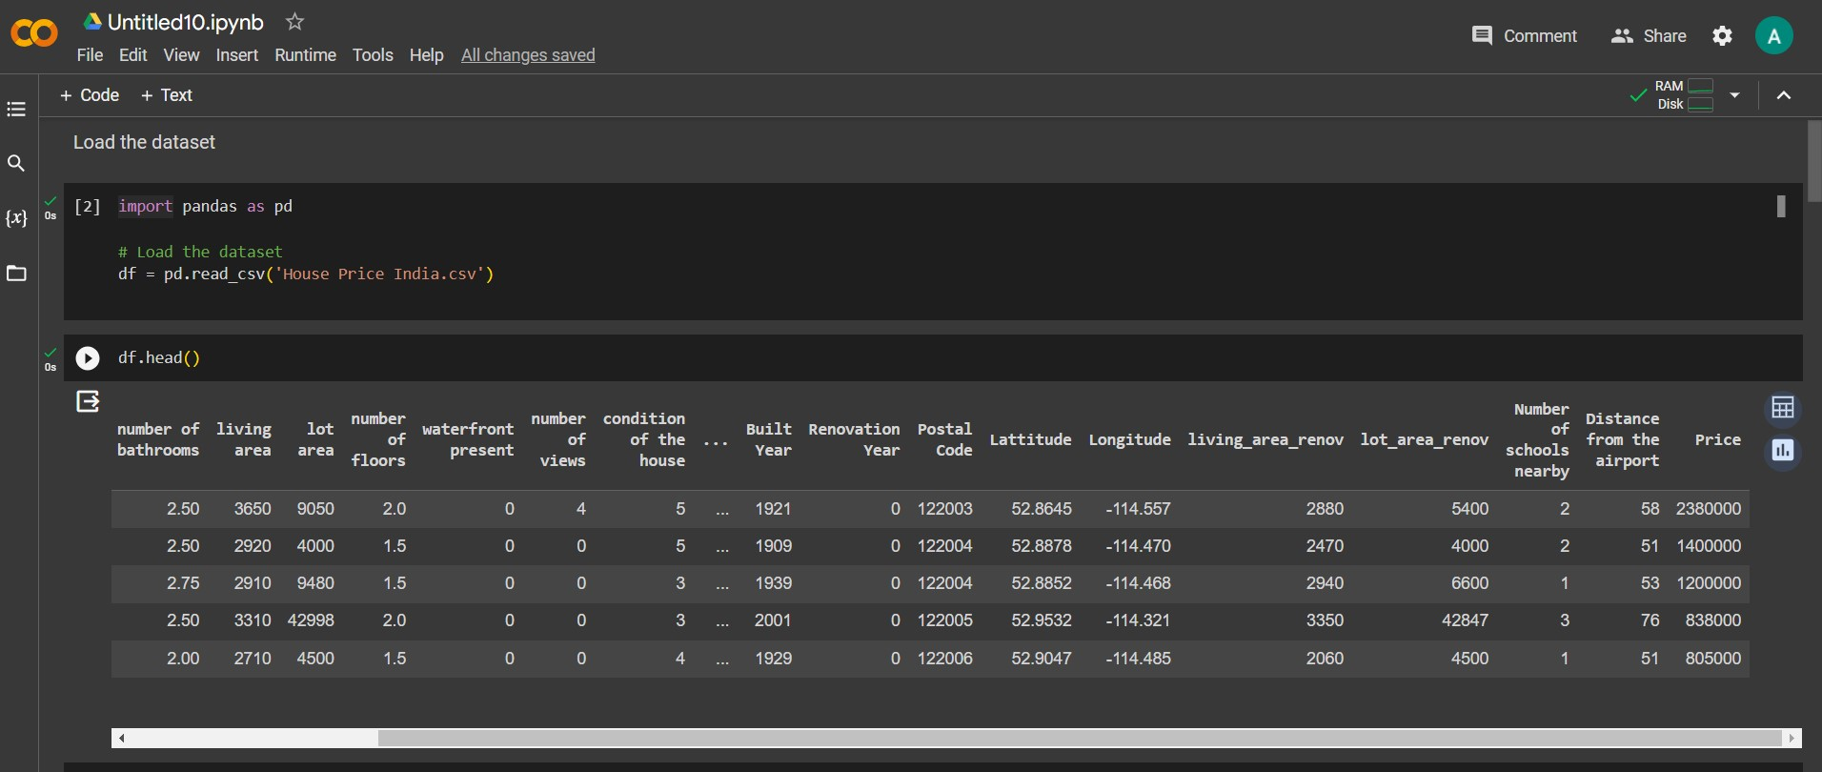

Univariate Analysis :

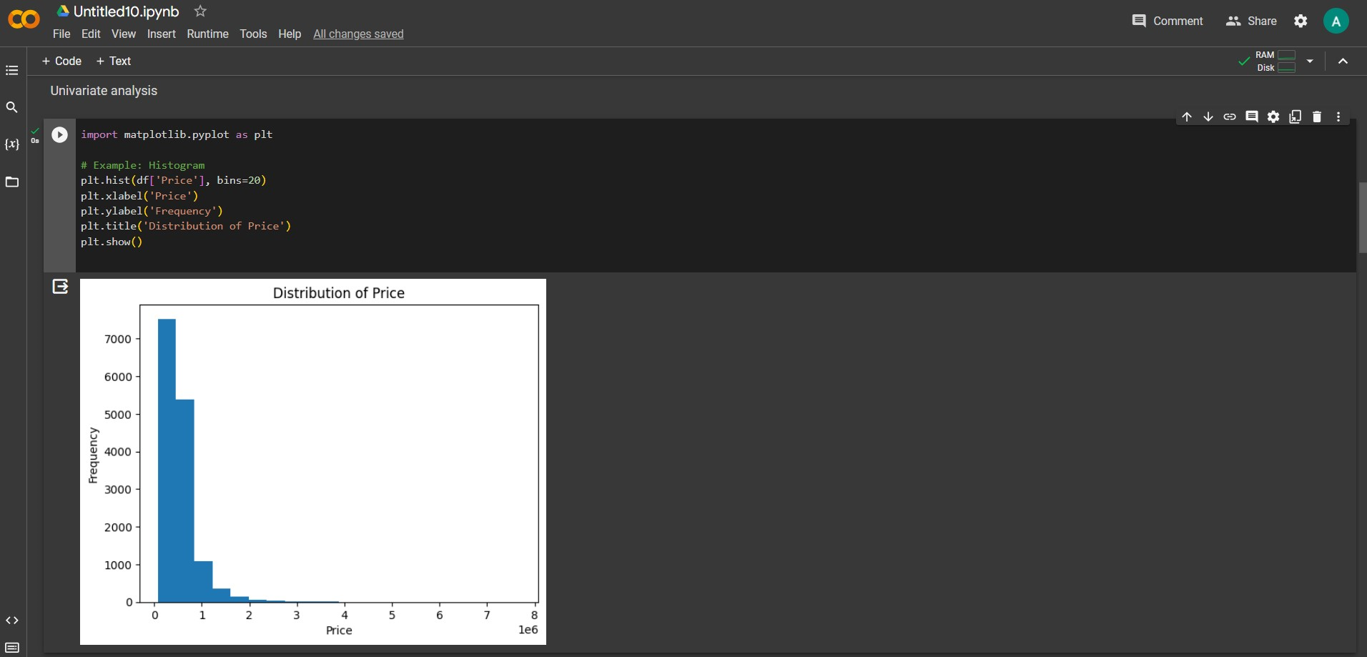

Bi - Variate Analysis :

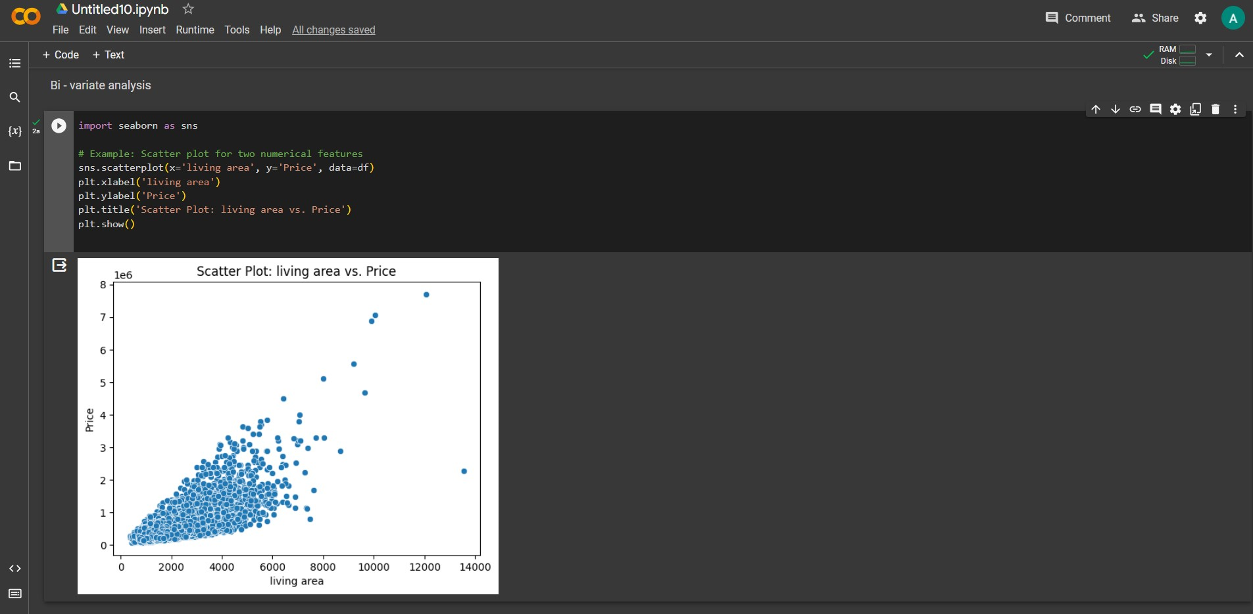

Multi-Variate Analysis :

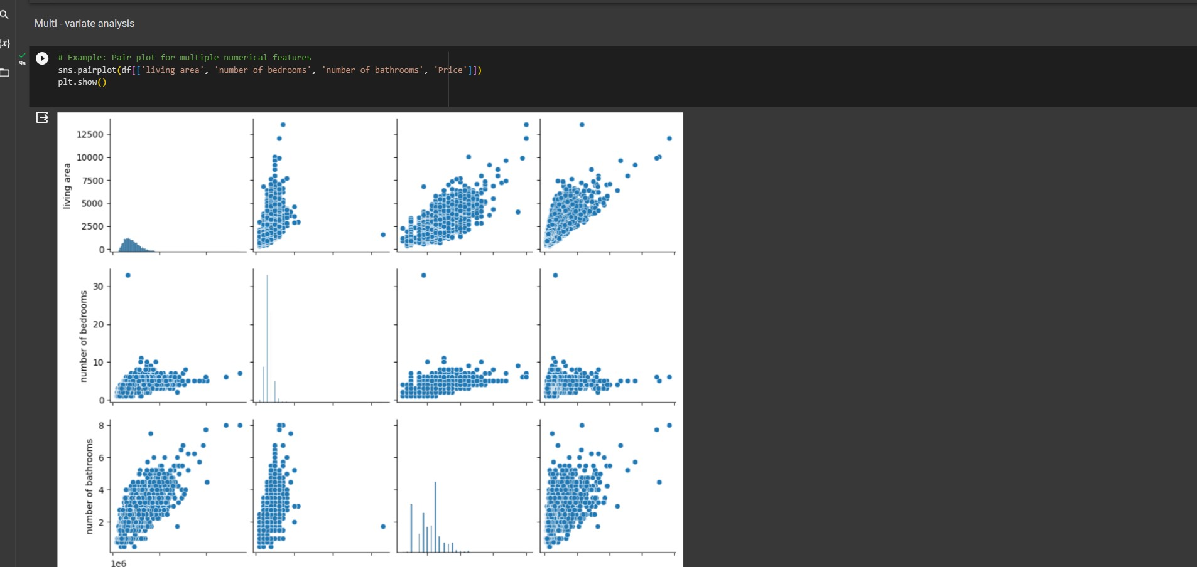

Descriptive statistics on the dataset :

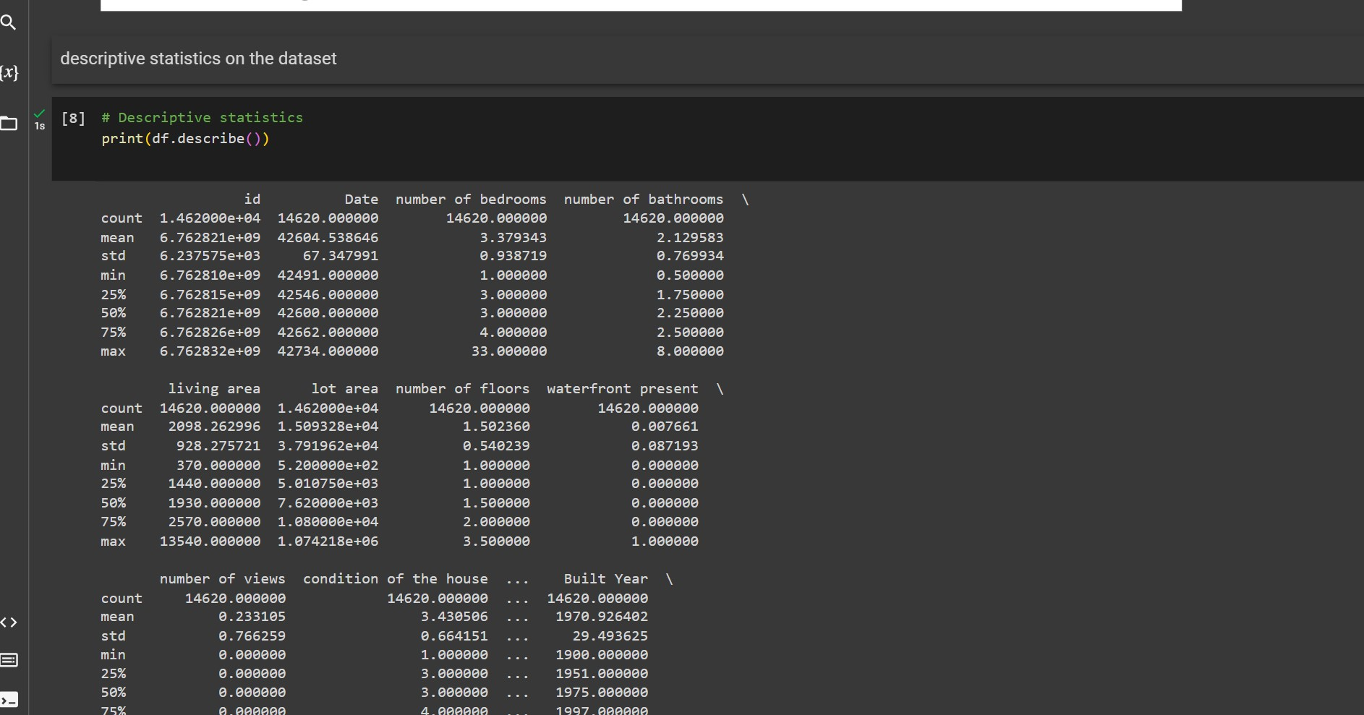

Handle the Missing values :

